**Brain Computer Interface (BCI)**

Brain Computer Interface (BCI) technology is a powerful communication tool between users and systems. It does not require any external devices or muscle intervention to issue commands and complete the interaction. The research community has initially developed BCIs with biomedical applications in mind, leading to the generation of assistive devices. They have facilitated restoring the movement ability for physically challenged or locked-in users and replacing lost motor functionality. The promising future predicted for BCI has encouraged research community to study the involvement of BCI in the life of non-paralyzed humans through medical applications.

Brain-computer interfaces (BCIs) acquire brain signals, analyze them, and translate them into commands that are relayed to output devices that carry out desired actions. BCIs do not use normal neuromuscular output pathways. The main goal of BCI is to replace or restore useful function to people disabled by neuromuscular disorders such as amyotrophic lateral sclerosis, cerebral palsy, stroke, or spinal cord injury. From initial demonstrations of electroencephalography-based spelling and single-neuron-based device control, researchers have gone on to use electroencephalographic, intracortical, electrocorticographic, and other brain signals for increasingly complex control of cursors, robotic arms, prostheses, wheelchairs, and other devices. Brain-computer interfaces may also prove useful for rehabilitation after stroke and for other disorders. In the future, they might augment the performance of surgeons or other medical professionals. Brain-computer interface technology is the focus of a rapidly growing research and development enterprise that is greatly exciting scientists, engineers, clinicians, and the public in general. Its future achievements will depend on advances in 3 crucial areas. Brain-computer interfaces need signal-acquisition hardware that is convenient, portable, safe, and able to function in all environments.

# BCI WORKING

In principle, any type of brain signal could be used to control a BCI system.

The most commonly studied signals are electrical signals from brain activity measured from electrodes (silicon chips) on the scalp, on the cortical surface, or in the cortex.

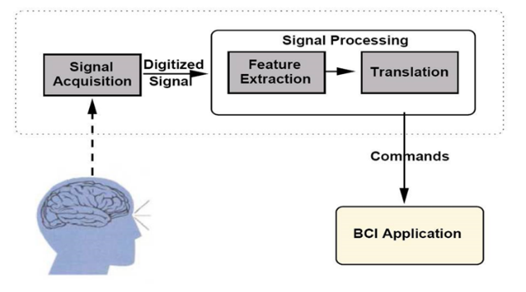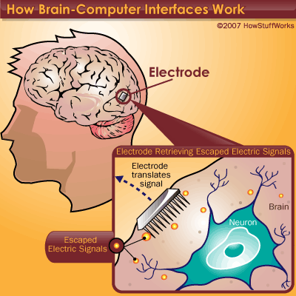

Components of a BCI System

1) Signal Acquisition,

2) Feature Extraction,

3) Feature Translation, and

4) Device Output

These 4 components are controlled by an operating protocol that defines the onset and timing of operation

### COMPONENTS

### **Signal Acquisition**

Signal acquisition is the measurement of brain signals using a particular sensor modality (eg, scalp or intracranial electrodes for electro physiologic activity, fMRI for metabolic activity). The signals are amplified to levels suitable for electronic processing (and they may also be subjected to filtering to remove electrical noise or other undesirable signal characteristics, such as 60-Hz power line interference). The signals are then digitized and transmitted to a computer.

### **Feature Extraction**

Feature extraction is the process of analysing the digital signals to distinguish pertinent signal characteristics (i.e., signal features related to the person's intent) from extraneous content and representing them in a compact form suitable for translation into output commands. These features should have strong correlations with the user's intent. Because much of the relevant (i.e., most strongly correlated) brain activity is either transient or oscillatory, the most commonly extracted signal features in current BCI systems are time-triggered EEG or ECoG response amplitudes and latencies, power within specific EEG or ECoG frequency bands, or firing rates of individual cortical neurons. Environmental artefacts and physiologic artefacts such as electromyographic signals are avoided or removed to ensure accurate measurement of the brain signal features.

### **Feature Translation**

The resulting signal features are then passed to the feature translation algorithm, which converts the features into the appropriate commands for the output device (i.e., commands that accomplish the user's intent). For example, a power decrease in a given frequency band could be translated into an upward displacement of a computer cursor, or a P300 potential could be translated into selection of the letter that evoked it. The translation algorithm should be dynamic to accommodate and adapt to spontaneous or learned changes in the signal features and to ensure that the user's possible range of feature values covers the full range of device control.

### **Device Output**

The commands from the feature translation algorithm operate the external device, providing functions such as letter selection, cursor control, robotic arm operation, and so forth. The device operation provides feedback to the user, thus closing the control loop.

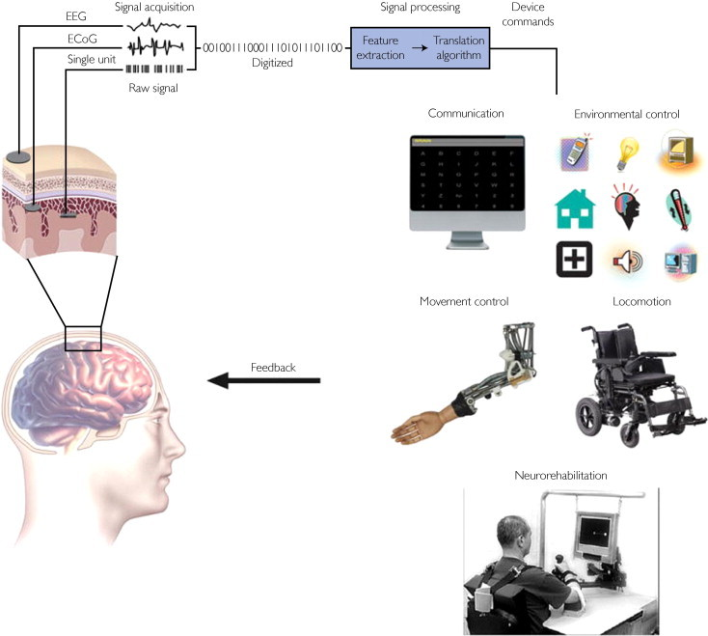

BCI system showing signal detection, processing and command outputs.

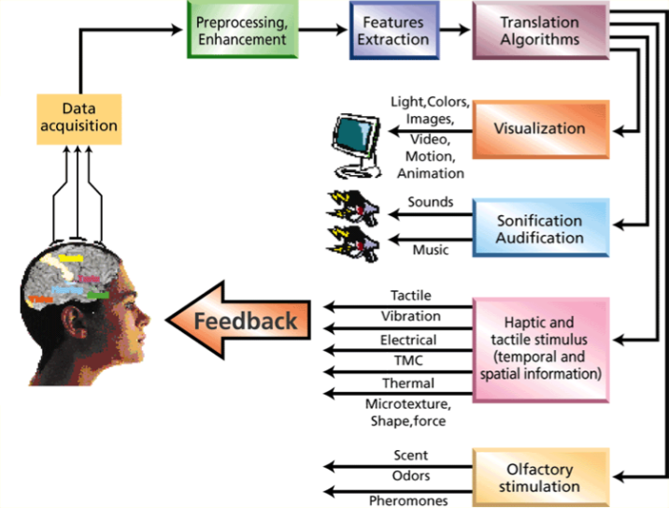

Types of operations done after signals translated

FUTURE APPLICATIONS

* Provide additional channel of control in computer games.
* Provide disabled people with communication, environment control, and movement restoration.
* Provide control of devices such as wheelchairs, vehicles, or assistance robots for people with disabilities.
* Control robots that function in dangerous or inhospitable situations (e.g., underwater or in extreme heat or cold).
* Develop intelligent relaxation devices and passive devices for monitoring behaviors such as long-term drug effects, evaluating psychological state, therapeutic methods, etc.
* Monitor stages of sleep, Bionics/Cybernetics, Memory Upload/Download, Dream Capture etc.
* Facebook Brain-Computer Interface for typing and skin-hearing.
* Neuralink - An Initiative by Elon Musk (Neuralink : How the Human Brain Will Download Directly from a Computer).